Preparation of Papers for
ENERGY OF MOLDOVA - 2016 CONFERENCE
Mihai TIRSU, Vladimir BERZAN, Mihail SIT
Affiliation of author/authors (only institution, without address)

Abstract –These instructions give you guidelines for preparing an A4 (21cm x 29.7cm) paper in two-column format for the Proceedings of the “Energy of Moldova-2016”, Chisinau, 29 September – 1 October, 2016. Use this document as a template if you are using Microsoft Word 2003 or later. This part of the paper (the Abstract) must contain at about 200 words and must emphases the main contributions of the authors to the subject, the essential features of the proposed solutions and the original results obtained.
Keywords – a maximum of five keywords
pregătirea articlolelor pentru
conferinţa energetica moldovei - 2016
Mihai TIRŞU, Vladimir BERZAN, Mihail ŞIT
Afilierea autorului/autorilor (numai a instituţiei, fără adresă)
Rezumat – Aceste instrucţii vă oferă asistenţă în procesul de pregătire a articolului în format A4 (21cm x 29.7cm) în două coloane pentru Volumul de lucrări al Conferenţei “Energetica Moldovei – 2016”, care va avea loc la Chişinău, 29 septembrie – 01 octombrie, 2016. Utiliza-ţi acest document în calitate de şablon dacă folosiţi redactorul MS WORD 2003 sau mai superior. Această parte a lucrării (Rezumatul) trebuie să conţină în jur de 200 cuvinte şi să facă accent asupra contribuţiilor principale ale autorilor la subiect, trăsăturile de bază ale soluţiei propuse şi originalitatea rezultatelor obţinute.
Cuvinte cheie – maximum cinci cuvinte

ПОДГОТОВКА СТАТЕЙ ДЛЯ КОНФЕРЕНЦИИ
ЭНЕРГЕТИКА МОЛДОВЫ - 2016
М.С. Тыршу, В.П. Берзан, М.Л. Шит
Организация автора/авторов (только организация без адреса)
Реферат –Эти инструкции даны Вам в качестве шаблона для подготовки статьи на формате А4 (21см х 29.7см) в две колонки, которые будут опубликованы в сборнике трудов «Энергетика Молдовы – 2016), что буден проведена в Кишиневе в период с 29-го Сентября по 01-го Октября 2016 года. При написании статьи используйте редактор WORD 2003 или более позднюю версию. Эта часть работы (Реферат) должна содержать около 200 слов и сделать акцент на основной вклад авторов, особенности предложенного решения и оригинальность полученных результатов.
Ключевые слова – максимум пять слов

1. LANGUAGE
The paper must be written in Romanian, English or Russian, clear and unambiguous. In order to avoid 'typos', you should check the spelling of your text by means of a computer thesaurus. Abstract and paper title must be written in English, Russian and Romanian. In case of necessity Organizing Committee will help with translation of abstract.
2. WE EXPECT YOU
To send us a paper written in WORD for Windows, both .DOC and .PDF format, via electronic system from conference site: www.em-2016.ie.asm.md or e-mail tirsu.mihai@gmail.com.
3. PAPER FORMAT
3.1 Paper length
The two-column paper length is strictly limited to a maximum of 8 (eight) pages including text and figures (please don’t number the pages).

3.2 First page layout
The title in the first page of the paper should be typed after the 4.2 cm interval from the top of the A4 page.
The title of the paper, author's name and affiliation should be page centered.

3.3 Margins
Paper size: A4 (21.x 29.7 cm)
The page margins are of 2cm, only the first page has the top margin of 4.2cm.
Main text of the paper: in two 8.25 cm width columns (the text in columns should be both-side justified).
Space between columns: 0.5cm. Please level the length of columns on last page.

4. FONTS
Text should be justified. Interval between type lines: automatic or single spaced. Use Times New Roman. Please do not intend the text, which should always start at the left side margin. Spaces are 10 pts. before and after: paragraph titles, equations, figures and tables. Spaces before subparagraph titles are of 10 pts.
We encourage to use the predefined styles (the style names begin with S, like “S text”, “S titlu figuri” etc.).
Fonts style and size is summarized in Table 1. Do not change the font sizes or line spacing to squeeze more text into the limited number of pages. Use italics for emphasis; do not underline.

Table 1 - Font Size and Style
 | size | style
Author's names | 13pts. | Bold
Affiliation | 11pts. | Normal
Title | 16pts. | BOLD UPPER CASE
Abstract text | 9pts. | Italic
Main text | 10pts. | Normal
Paragraph titles | 10pts. | BOLD UPPER CASE
Subparagraph titles | 10pts. | Bold
Reference titles | 8pts. | Italic
Biography | 8pts. | Normal / Italic
5. EQUATIONS
Number equations consecutively with equation numbers in parentheses flush with the right margin, as in (1). Please use the equation editor to create the equation. To make your equations more compact, you may use the solids ( / ), the exp function, or appropriate exponents. Use parentheses to avoid ambiguities in denominators.

$\int{ F(r,ϕ)} \text{dr} dϕ=[{σr}_{2} (2μ_{0})] \text{.}$ (1)

Be sure that the symbols in your equation have been defined before the equation appears or immediately following. Italicize symbols (T might refer to temperature, but T is the unit tesla). Refer to “(1),” not “Eq. (1)” or “equation (1),” except at the beginning of a sentence: “Equation (1) is ... .”
6. Tables, Figures and Graphs
Place them straight in the text, preferable at the top and bottom of each column. Place figure captions below the figures (centered); place table titles above the tables (left
Fig.1. Example of a graph

alignment). Large figures and tables may span both columns and place them at the end of the page, or, preferable at the end of the paper.
Figures and graphs may be in color but readable when
printed in black and white version. All the lettering should be large enough to be easily legible.
Use the abbreviation “Fig.” even at the beginning of a sentence. Do not abbreviate “Table.”
7. SYMBOLS AND ABBREVIATIONS
Define abbreviations and acronyms the first time they are used in the text, even after they have already been defined in the abstract. Do not use abbreviations in the title unless they are unavoidable.
Symbols and acronyms should be typed clearly and should be defined the first time they appear. Use the International System (SI) of units.
8. Conclusions
Low quality (Romanian/English/Russian, content) and lately submitted manuscripts will not be published in the Proceedings and will be cancelled from the final program of the Conference.
REFERENCES
References should be included in the main text using square brackets [1]. A numerical list of reference should be given at the end of the paper in the order of appearance. Italicize only the paper or book title.

- G. O. Young, Synthetic structure of industrial plastics, Plastics, 2nd ed. vol. 3, J. Peters, Ed. New York: McGraw-Hill, 1964, pp. 15–64
- T. Ambros, P. Todos, L. Cantemir, A. Campeanu, Modern electric conferences, Proceedings of The 4th International Conference on Electromechanical and Power Systems SIELMEN’03, Chisinau, September 26-27, 2003, pp.1-5

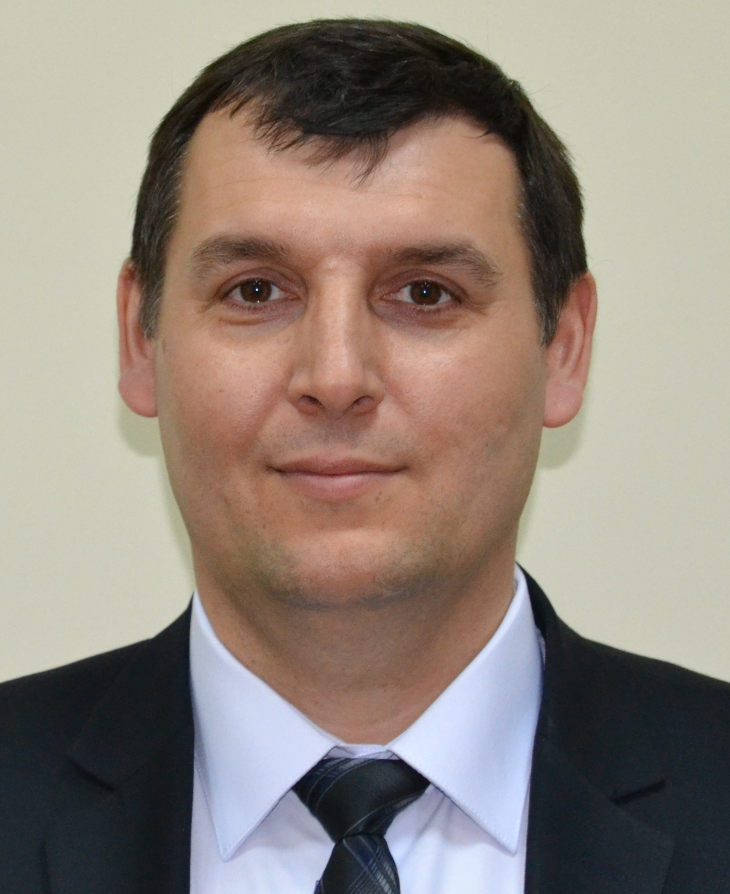
First A. Author and the other authors are encouraged to include short biographies (optional) at the end of regular papers. The first paragraph may contain a place and/or date of birth. Next, the author’s educational background is listed. The author’s major field of study should be lower-cased.
The other paragraph begins with the author’s title and last name. If a photograph is provided, the biography will be indented around it. The photography is placed at the top left of the biography. Personal hobbies will be deleted from the biography.

